

**Practice Assignment 1**

Your manager wants to see a report on your latest sales figures. They've requested an executive summary of:

* Which month and year had the most profit?
* Where is the company seeing the most success (by country/region)?
* Which product and segment should the company continue to invest in?

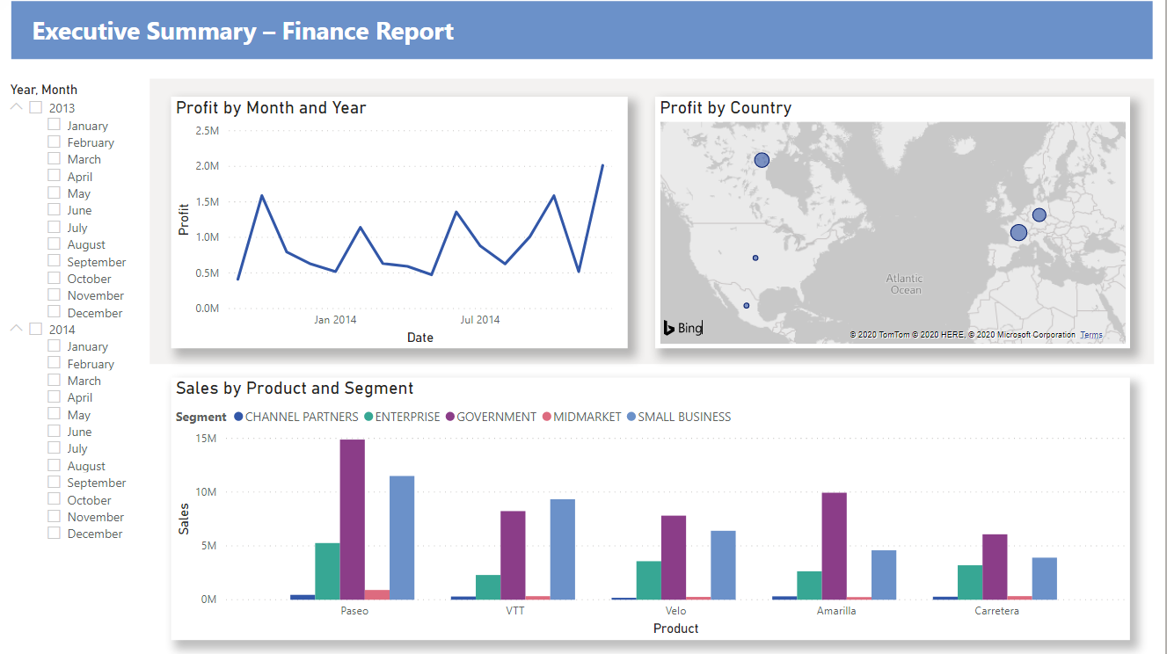

**Steps**

Transformation

1. Change Units sold to whole number.
2. Convert Segment column to uppercase
3. Shorten the column name from **Month Name** to just **Month**
4. The Montana product was discontinued last month, so we want to filter this data from our report to avoid confusion.
5. Dax Measure: to add all the numbers in the Units Sold column.
6. Generate a Calendar table of all dates between January 1, 2013, and December 31, 2014.

Data Modelling

1. Create a relationship between 2 tables on date

Report generation

